**Executive Summary**

Project-Beggars

This report examines Beggars Pizza’s customers’ behaviors and tendencies. We utilized Yelp, point of sales data, and ACS census information to analyze how review counts and ratings from Yelp impact store performance, how coupon usage correlates to new customers, and census data to see millennial ordering tendencies.

**How do Yelp reviews impact store performance?**

*Methodology:* We placed stores into groups (“Disney Buckets”) based on Angelo’s intuition of operational efficiency and sales volume to measure total Yelp review counts by group and average Yelp rating by group.

*Findings:* The report shows that the average Yelp rating throughout the 25 unit chain is approximately 3 stars. As expected, stores in top bucket “Mickey” have both the highest average rating and the most review counts, and stores in the lowest bucket “Goofy” have the fewest total review counts. Stores in the middle buckets “Minnie” and “Donald” have similar ratings and review counts. From our analysis, it appears that the amount of review counts a store has is indicative of how the store is performing.

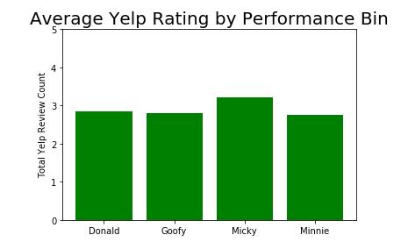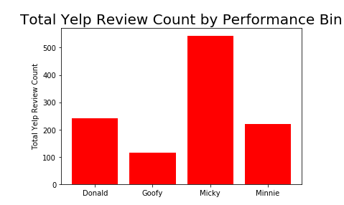

**Do coupons create new customers?**

*Methodology:* We analyzed point of sales data to derive the percentage of total orders redeeming a coupon(“% Coupons”) and the percentage of new customers(“% New Customers”). We took all stores with data for the time series 2014 – 2018 and plotted the % Coupons, and % New Customers over this time period. We then ran a regression model to see how the two are correlated company-wide as well as at the individual store level.

*Findings:* The report shows that there are definitive peaks and valleys throughout each calendar year for both the percentage coupons redeemed and percentage of new customers at each individual store. However, contrary to our expectation, the regression analysis shows a pearson r of -.1857 throughout the chain which indicates a negative relationship of coupons redeemed leading to new customers. The regression analysis finds a mixture of positive and negative values at the individual store level. StoreID 10584 and 12168 have the strongest positive correlation of coupons leading to new customers in the chain and conversely, StoreID 122 and 10465 have the strongest negative correlation of coupons leading to new customers. Interestingly, the report also finds that the only Disney bucket to have a positive correlation is the top bucket “Mickey.”

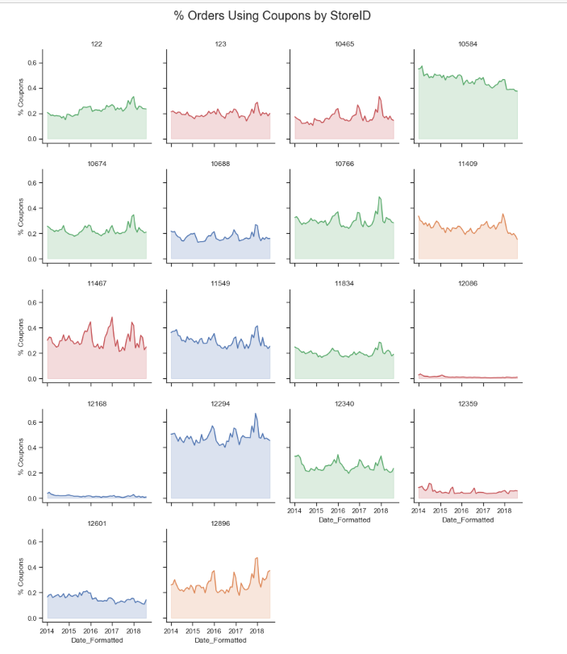

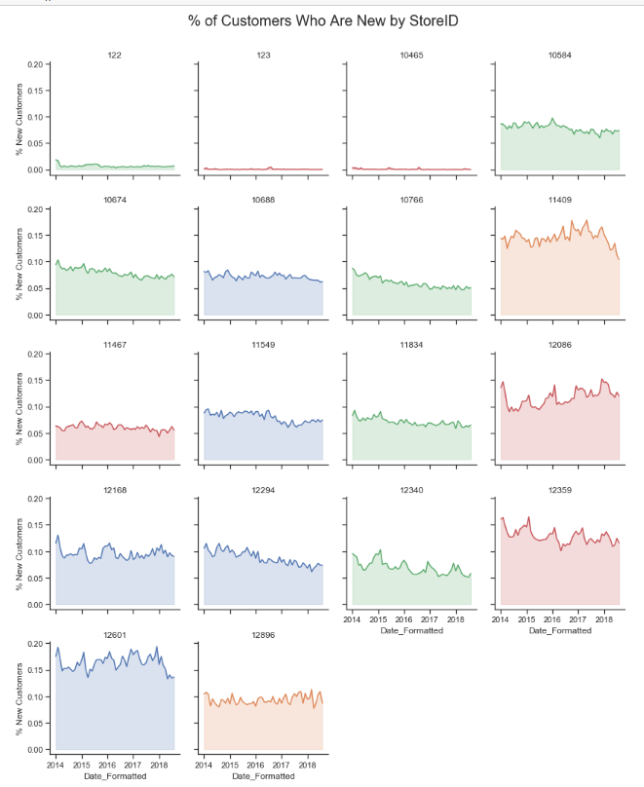

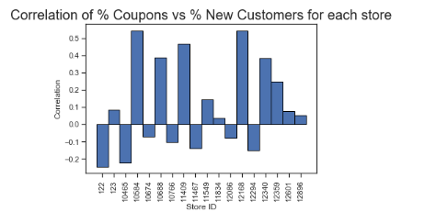

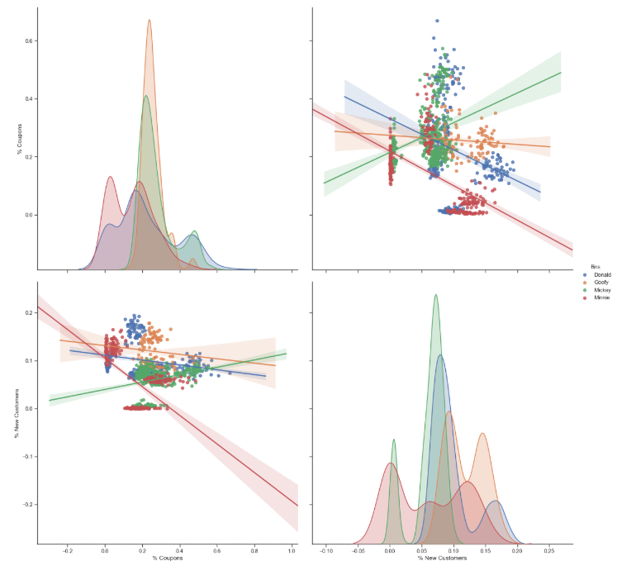

**What are millennial’s ordering tendencies?**

*Methodology:* We analyzed point of sales data to derive percentages of each order type(“Pick up”, “Deliveries”, “Walk In”, “Dine In”, and “Grubhub Deliveries”) and then graphed the findings in a box plot. We isolated the store with the highest percent of millennials living in the delivery area based on zip code information from each store’s customer database. We then analyzed the trend of Grubhub Orders as a percent of Total Deliveries.

*Findings:* The report shows that StoreID-12340 has the highest percentage of millennials living within any store’s delivery area. Drilling down further, the report shows that this store has the highest percentage of deliveries in its order mix. Interestingly, the report also finds that the percentage of customers who used the service Grubhub to place their delivery order has nearly doubled since 2014 and is trending upwards. From this analysis, it seems that millennials prefer a “convenient” order type and are utilizing new technology platforms regularly to place pizza orders with Beggars Pizza.

